**Edge Detection and Filtering Report**

**QUESTION 1:** What do you notice regarding the effect of changing the threshold? State both your observations and the reasons for the observations. Show your code, results and answer in the report.

**Code:** The code are illustrated in Figure 1.

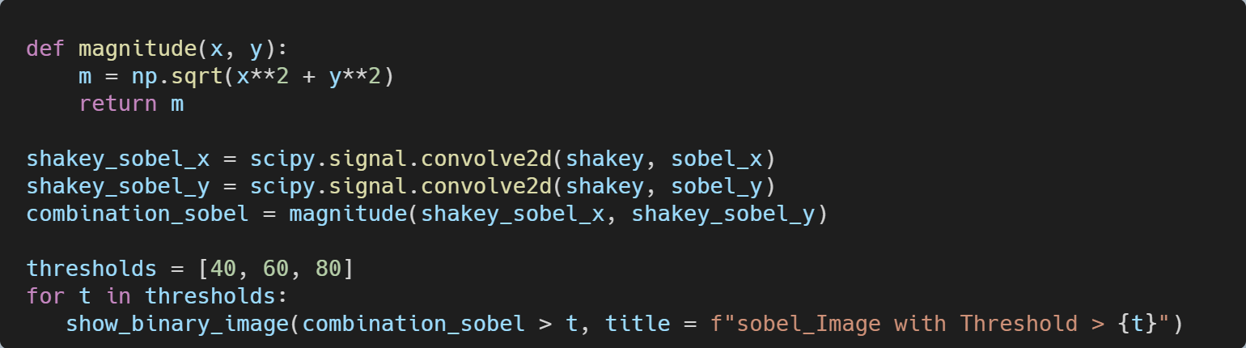

Figure 1

**Results:** The results are illustrated in Figure 2-4.

|  |  |  |
| --- | --- | --- |
| Figure 2 | Figure 3 | Figure 4 |

**Answer:** I applied Sobel filtering to the original image and set different threshold values at 40, 60, and 80. As the threshold increases, it is noticeable that the edges of the objects become thinner, and fewer details of the main object are retained. On the other hand, the background noise is better controlled, leading to the disappearance of some edges in the background.

The reason for this phenomenon is that the threshold filters out insignificant points. If the gradient magnitude of a point does not exceed the threshold, it will not appear in the image. As the threshold value increases from 40 to 80, only the stronger edges are preserved. Therefore, the threshold has a significant impact on aspects such as edge selection, noise reduction, and it can even lay a foundation for further processing in neural networks.

**QUESTION 2:** What do you notice regarding the difference between Sobel and Roberts? State both your observations and the reasons for the observations.

**Results:** The results are illustrated in Figure 5-7.

|  |  |  |
| --- | --- | --- |
| Figure 5 | Figure 6 | Figure 7 |

**Answer:** When comparing images processed by Sobel and Roberts filters, it's evident that the Roberts-filtered images show fewer edges and points. It is also noticeable that background objects are less detectable with Roberts filtering. However, labels connected to the main object, as well as the characters on the labels, become more distinct. Additionally, the edges in the Roberts-filtered images are thinner compared to those processed by Sobel filtering with the same threshold value. Notably, when the threshold is set to 80, some edges on the top of the main object become difficult to detect with the Roberts filter.

There are two main reasons for the differences between these two filters. First, the Roberts filter uses a 2x2 kernel, whereas the Sobel filter uses a 3x3 kernel. A larger kernel allows the detection of more edge details, which is why the Roberts filter misses some finer details. Second, the Sobel filter's kernel weights vertical, horizontal, and diagonal directions more evenly, resulting in more continuous edges. In contrast, the Roberts filter emphasizes edges at 45 and 135 degrees, which leads to many vertical and horizontal edges being cut off or appearing less prominent, such as the label borders connected to the main object.

**QUESTION 3:** What do you notice regarding the difference between magnitude and absolute when calculating the edge? State both your observations and the reasons for the observations.

**Results:** The results are illustrated in Figure 8-11.

|  |  |
| --- | --- |
| Figure | Figure |

|  |  |
| --- | --- |
| Figure | Figure |

**Answer:** The difference between calculating edges using magnitude and absolute values is subtle but noticeable. At the same threshold value, the absolute method tends to miss some fine details, especially in more complex parts of the main object. Additionally, there are instances where noise appears more prominently in areas that should be blank.

Several factors contribute to these differences. First, the absolute sum typically yields larger values compared to the magnitude method. This means that certain points may not surpass the threshold when using the magnitude method but can exceed it with the absolute sum, resulting in more noise or unintended edges. Furthermore, the magnitude method provides a more balanced evaluation of edges across all directions, while the absolute method places more emphasis on vertical and horizontal edges. As a result, the absolute method may struggle to detect inclined edges, leading to blurred or discontinuous edges in complex regions.